**Fall 2019 COMP 7706 Software Architecture**

**Final Project Test Document**

1. As a user, I want to change my password and/or full name.
   1. Initial Users table before change  
      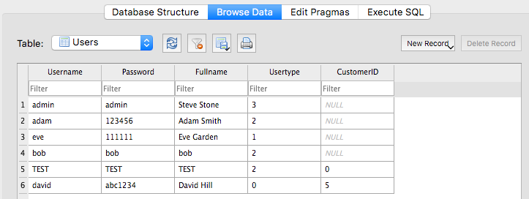
   2. Screen to update password and full name  
      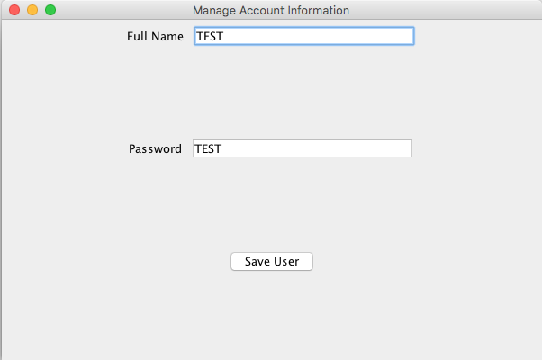
   3. Verification of Successful change  
      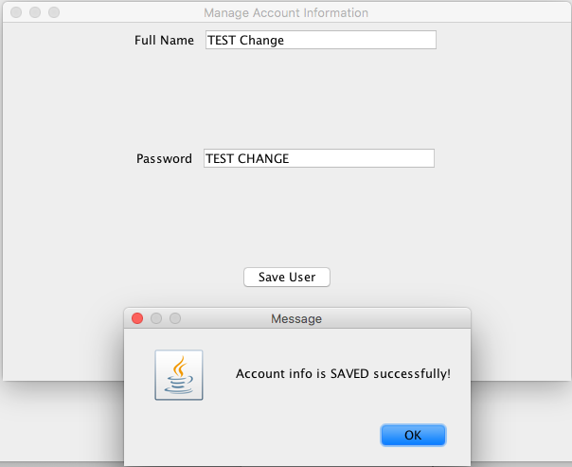
   4. Users table after change  
      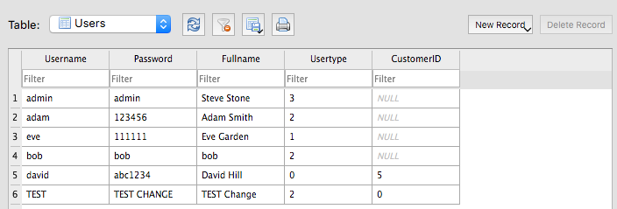
2. As an admin, I want to add a new user into the system.
   1. Initial Users table before adding new user  
      
   2. Verification of successfully adding new user

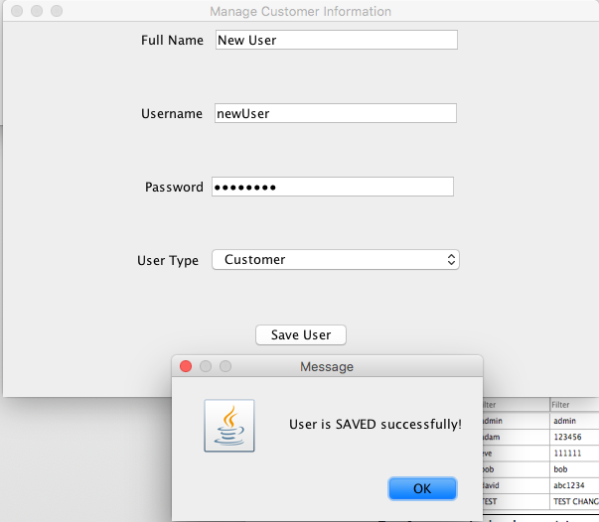

* 1. Users table after addition of new user  
     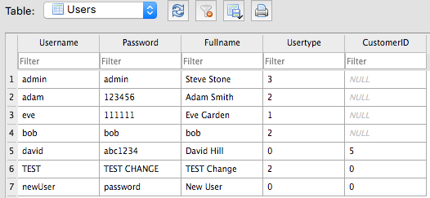

1. As an admin, I want to update the type/class of a user into the system (e.g., from cashier to manager).
   1. Initial Users table before changing the user type  
      
   2. Update user with the username TEST. Initial form population from username.  
      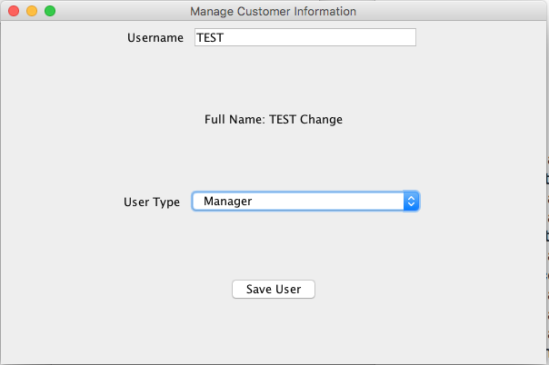
   3. Verification of successful update  
      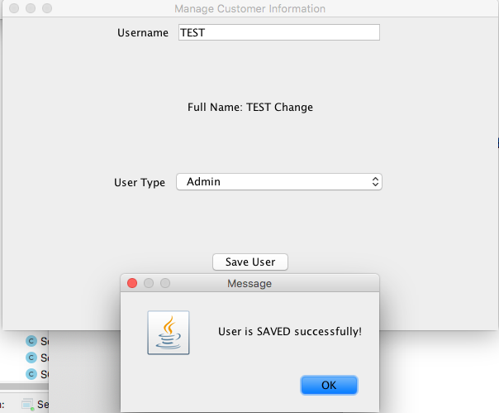
   4. Users table after changing the user type  
      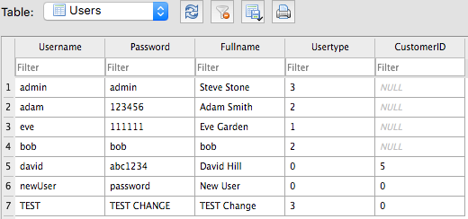
2. As a manager, I want to add a new product or update a current product in the system.
   1. Initial Products table before adding new product  
      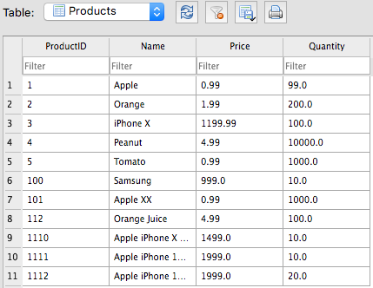
   2. Verification of successfully adding new product  
      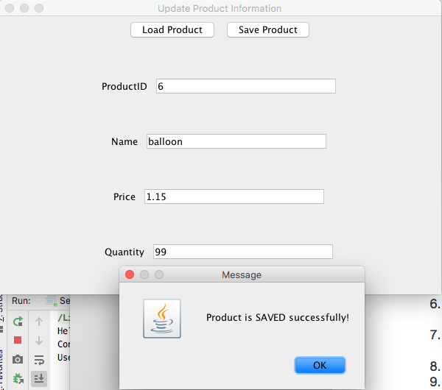
   3. Products table after adding new product  
      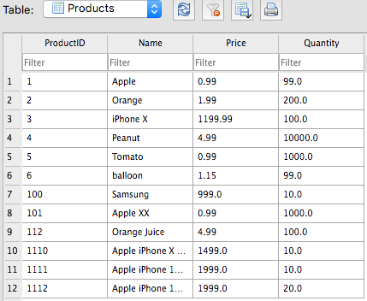
   4. Populated values from loading ProductID 4  
      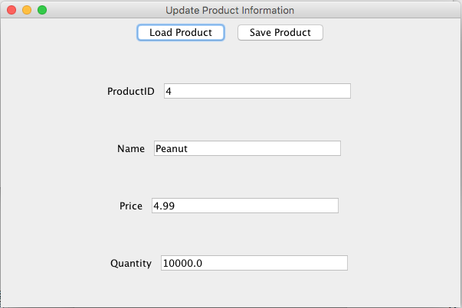
   5. Successful verification of updating product information  
      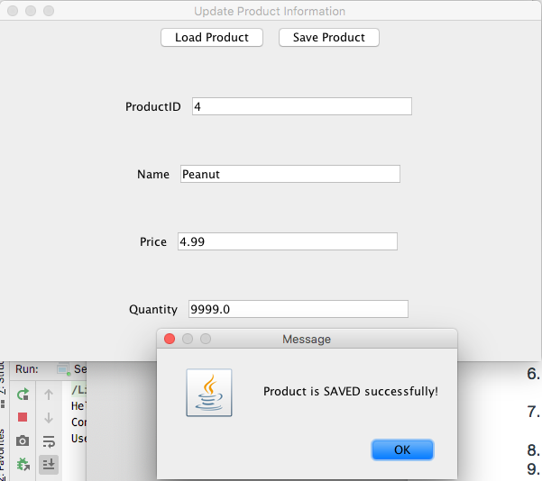
   6. Products table after updating product with ProductID = 4  
      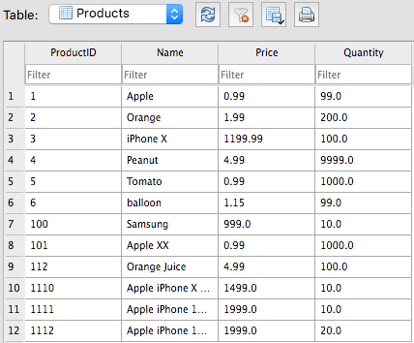
3. As a manager, I want to view a summary report of sales from the system.

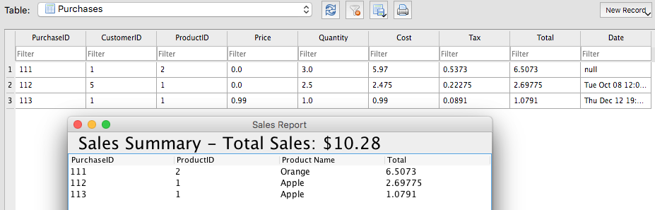

1. As a cashier, I want to add a new customer or update a current customer in the system.
   1. Initial Customers table before adding a new customer  
      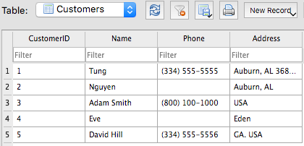
   2. Verification of successfully adding new customer  
      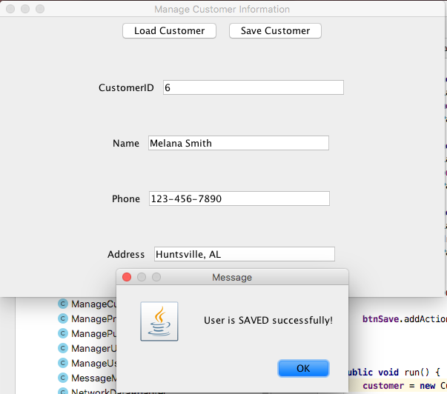
   3. Customers table after adding new customer  
      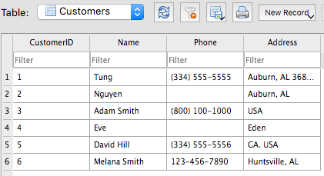
   4. Verification of successfully updating an existing user  
      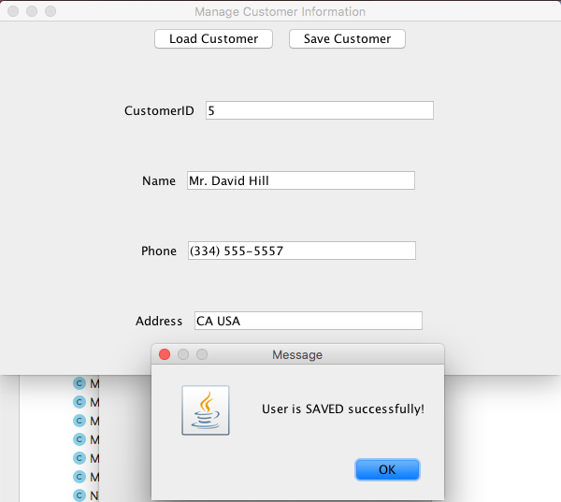
   5. Customers table after updating customer with CustomerID = 5

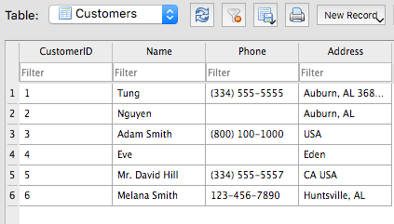

1. As a cashier, I want to add a new purchase or update a current purchase (only price and quantity) in the system.
   1. Initial Purchases table before adding a new purchase  
      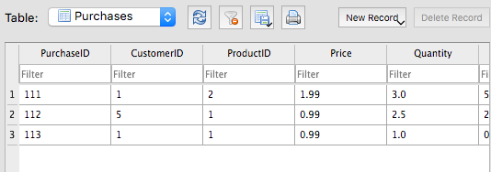
   2. Verification of successfully adding new purchase  
      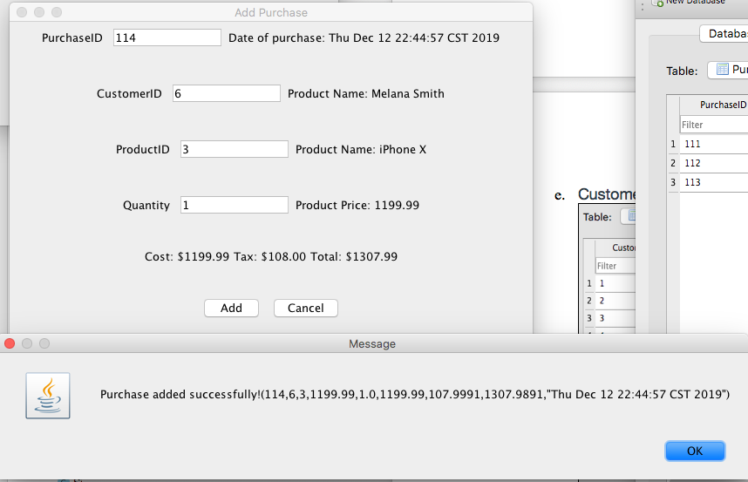
   3. Purchases table after adding a new purchase  
      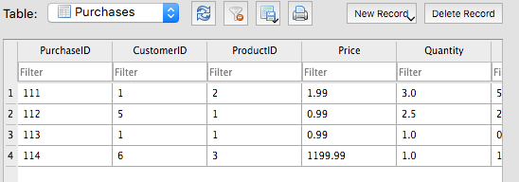
2. As a customer, I want to add a new purchase into the system.
   1. Initial Purchases table before adding a new purchase into the system  
      
   2. Verification of successfully adding a new purchase  
      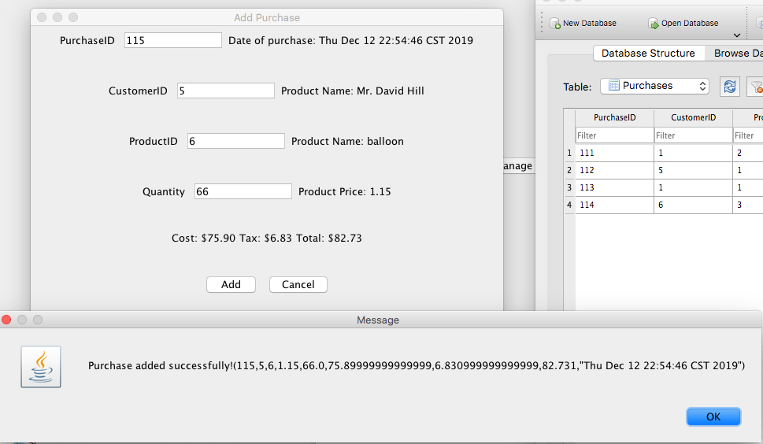
   3. Purchases table after adding new purchase  
      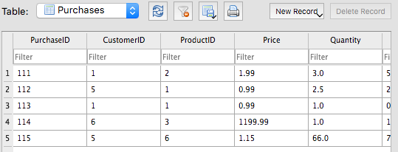
3. As a customer, I want to view my purchase history into the system.
4. As a customer, I want to search for product information (based on name, price) in the system.